Project Phase I: User Manual

*Versions 2.0*

CS/SE 6362 Advanced Software Architecture (Fall 2015)

**Submitted to:**

**Dr. Lawrence Chung,**

**Associate Professor,**

**Department of Computer Science,**

**The University of Texas at Dallas,**

**Richardson, TX -75080**

**Submitted By:** Team Name: Quick Search

**Sruthi Chappidi,** [**sxc105920@utdallas.edu**](mailto:sxc105920@utdallas.edu)**,**

**Barbara Maweu,** [**bmk101020@utdallas.edu**](mailto:bmk101020@utdallas.edu)

**Maryellen Oltman,** [**mco130030@utdallas.edu**](mailto:mco130030@utdallas.edu)

**Twinkle Sharma,**[**txs151730@utdallas.edu**](mailto:txs151730@utdallas.edu)**.**

**Team Website:** [**www.utdallas.edu/~maryellen.oltman**](http://www.utdallas.edu/~maryellen.oltman)

The Application will be available on our team website. Welcome screen will be displayed with text box to enter the queries that need to be circularly shifted and sorted in alphabetical order

**Step 1: Enter the Input String. $ delimiter is used to separate each line in the input**

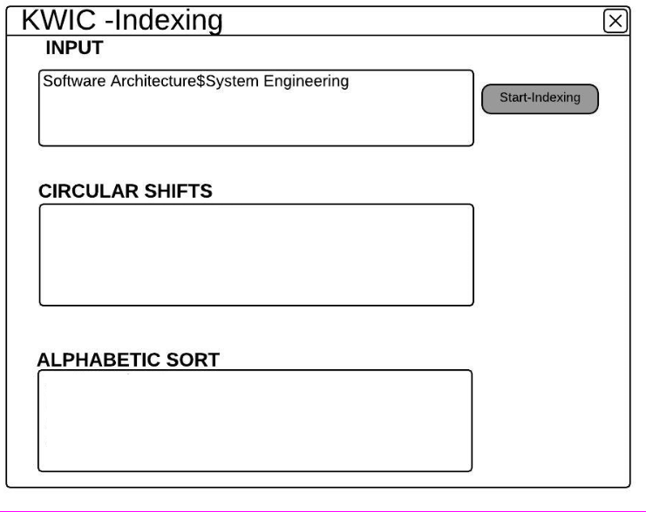

**Step 2: Press Start-Index button to start process**

Upon entering the desired search query, the user will need to press Start-Indexing button to start the process of Circular Shift followed by Alphabetic Sort.

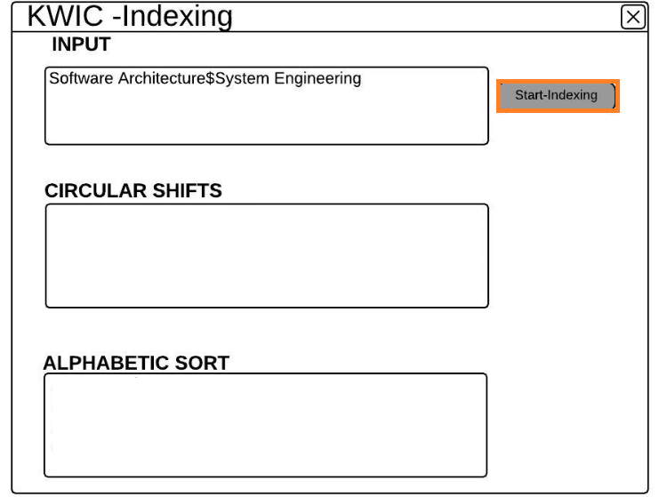

**Step 3: Display of Circular Shifted and Alphabetically Sorted Lines**

The Circular shifted lines will be displayed in the 2nd panel and in the 3rd panel the Alphabetically sorted line will be displayed

